Read the following extract from Act 1 Scene 3 of The Merchant of Venice and then answer the question that follows.

At this point in the play Shylock is speaking to Antonio. Antonio has asked Shylock to lend him some money.

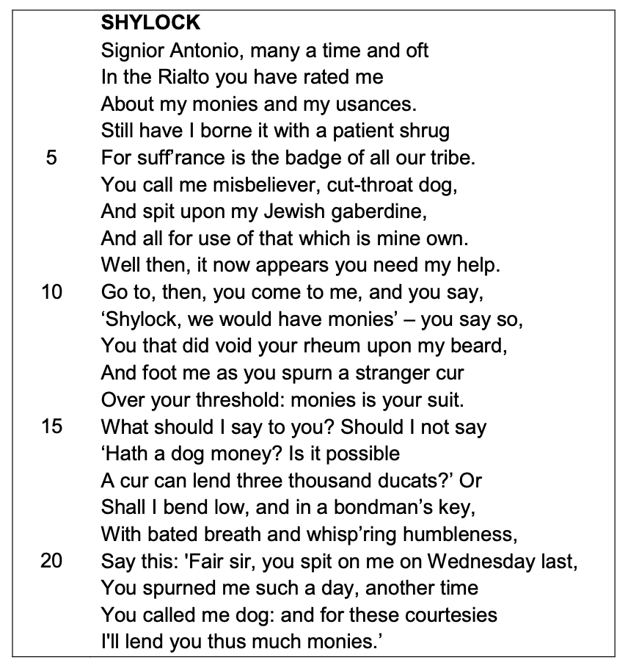

Starting with this speech, how does Shakespeare present Shylock’s feelings about the way he is treated?
Write about:
• how Shakespeare presents Shylock in this speech
• how Shakespeare presents Shylock in the play as a whole.
[30 marks]
AO4 [4 marks

Essay Plan

Thesis Statement:
- Reference the question ‘Shakespeare presents Shylock’s feelings about the way he is treated . . .’
- One surface meaning – Shakespeare used something . . .
- One deeper meaning – Shakespeare crafted a character to highlight/celebrate/criticise

Paragraph structure – you should use this model for each paragraph you write
CF: Mercy is presented in the court scene when…
EQ: When it says, ‘….’ Shakespeare is suggesting…
AQ: Shakespeare is showing that… because…
ZOOM: The word ….’ tells us that…. Because…
ZOOM: Also, the word ‘….’ shows us… because…
CON: In Elizabethan England,…
LINK: Therefore, Mercy is shown when…

You need to plan your response to this question

- What points will you make about the treatment of Shylock
- What characters will you focus on – how did they treat Shylock?
- What quotes will you use?
- Quote analysis – can you identify a number of points about this quote and how it shows the treatment of Shylock?
- Can you pick out writers methods and how they are used to show the treatment of Shylock?

The more you think about your essay and plan it the more effective it will be. You should attempt to write at least 2 sides for this essay.

Plan here

Here are some useful links to revision materials for The Merchant of Venice. Copy and paste them into a web browser to access.
- The Merchant of Venice Study Guide | Literature Guide | LitCharts
- Merchant of Venice Themes - GCSE English Literature Revision
- https://www.savemyexams.com/gcse/english-literature/aqa/17/revision-notes/1-shakespeare/how-to-answer-the-shakespeare-essay-question/context/
- Merchant of Venice Quotes - AQA GCSE English Literature

