**Physical Components of Fitness**

|  |  |  |
| --- | --- | --- |
| **Component of fitness** | **Definition** | **Sporting Example** |
|  | The ability of the cardiorespiratory system to supply oxygen and nutrients to the muscles to sustain low to medium intensity work to delay fatigue. |  |
|  | The ability of the muscular system to continue to contract at a light to moderate intensity to allow repetitive movements throughout a long event or game. |  |
|  | The maximum force that can be generated by a muscle or muscle group to improve forceful movements within an activity. |  |
|  | Distance divided by time to reduce time taken to move the body or a body part in an event or game. |  |
|  | The range of motion possible at a joint to allow improvements in technique. |  |
|  | The relative ratio of fat mass to fat-free mass in the body allowing variation in body composition dependent on the sport. |  |

Use the words below to add into the table.

Speed

Muscular Strength

Flexibility

Body Composition

Aerobic endurance

Muscular endurance

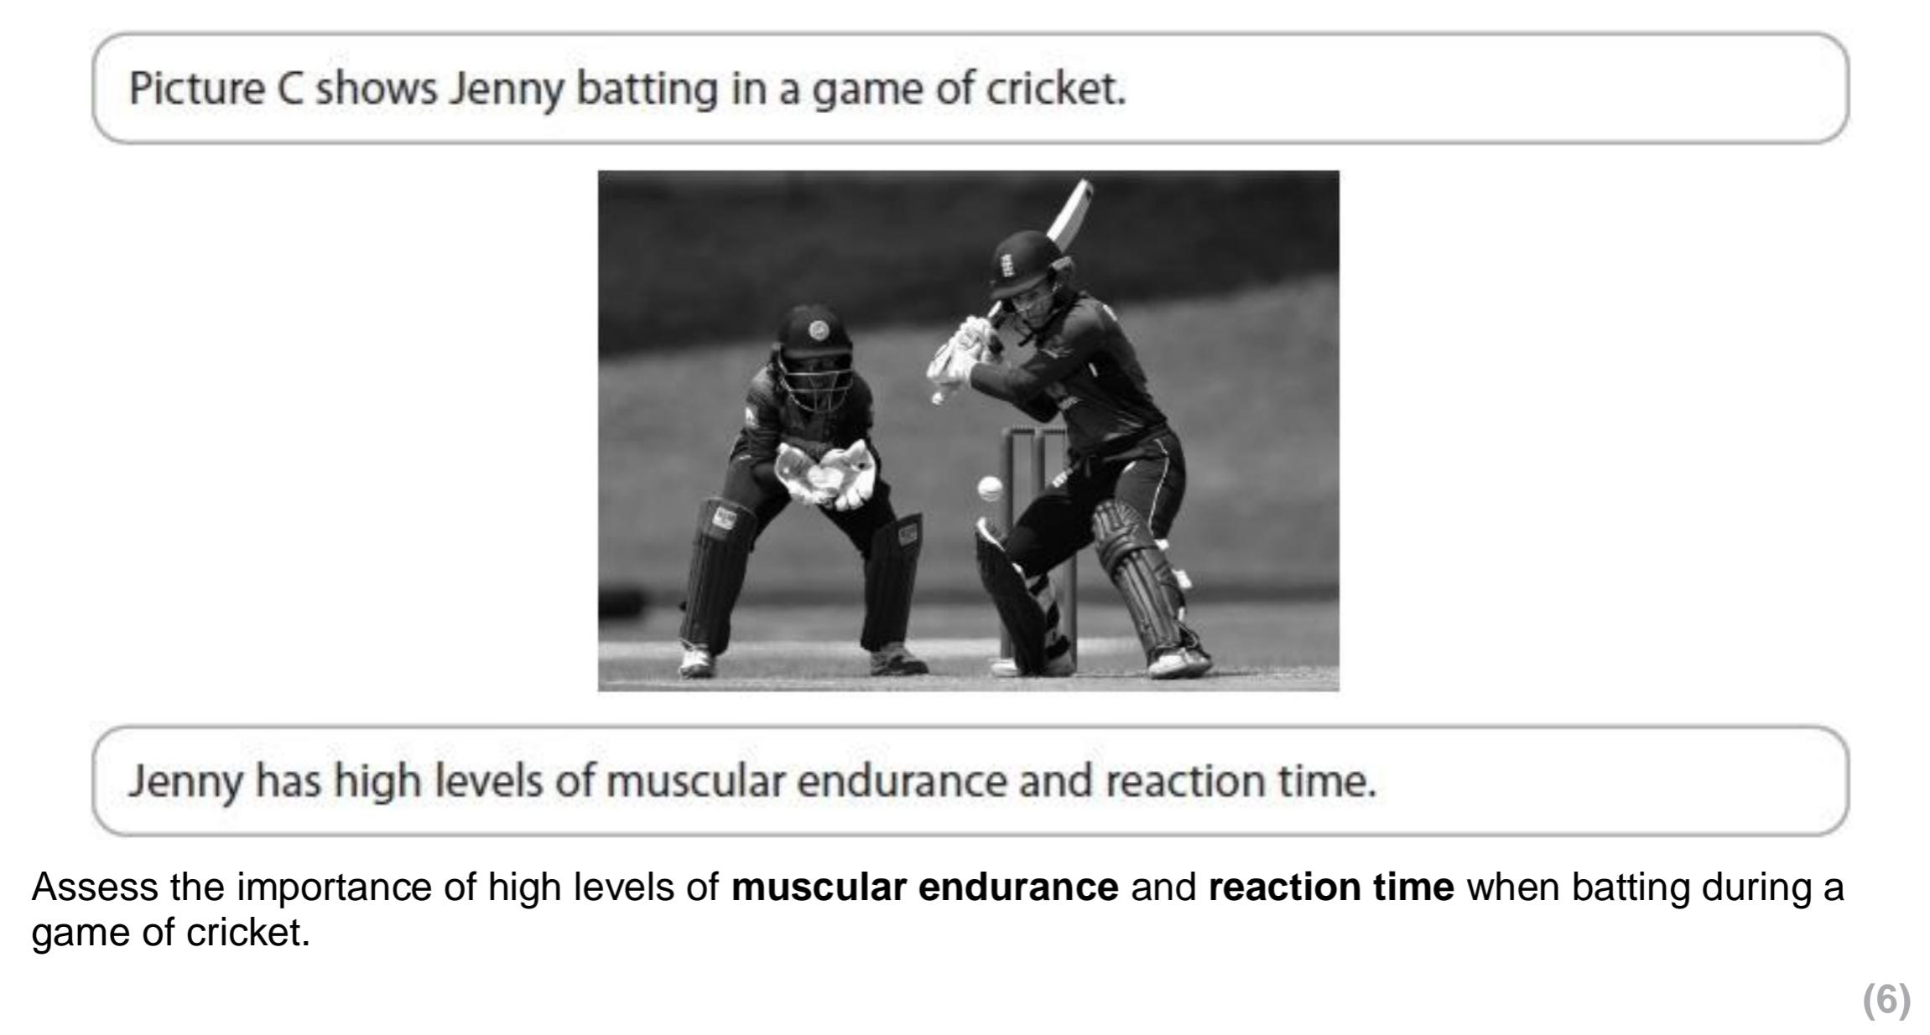Using the knowledge of the components discussed try to answer the following exam style question:

Remember it is a 6 mark question so think about how you are going to gain all 6 marks (Identify, Explain, Example).