**PSkill Components of Fitness**

|  |  |  |
| --- | --- | --- |
| **Component of fitness** | **Definition** | **Sporting Example** |
|  | The product of speed and strength to allow for explosive movements in sport. |  |
|  | The ability to change direction quickly to allow performers to out-manoeuvre an opponent. |  |
|  | The time taken between a stimulus and the start of a response, useful in fast-paced sports to make quick decisions about what to do. |  |
|  | The ability to maintain centre of mass over a base of support, useful to maintain positions in performance sports (static balance) or when on the move in any other sporting situation (dynamic balance). |  |
|  | The ability to move two or more body parts at the same time smoothly and efficiently, to allow effective application of technique. |  |

Co-ordination

Reaction Time

Agility

Use the words below to add into the table.

Power

Balance

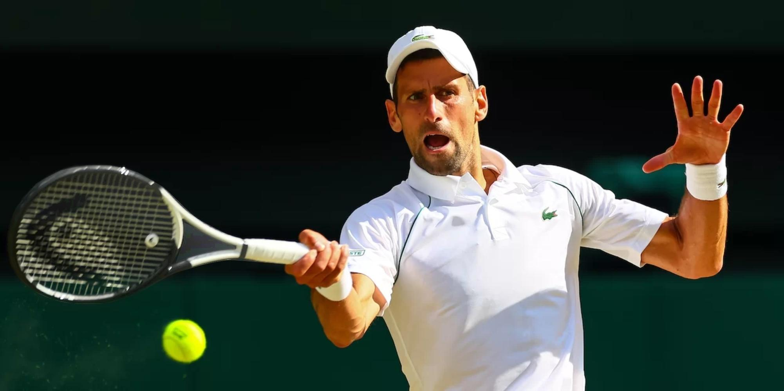The Picture below shows a Tennis player Returning a serve

Assess the importance of high levels of Co-Ordination and Balance in order to be successful in Tennis. (6)

[Grab your reader’s attention with a great quote from the document or use this space to emphasize a key point. To place this text box anywhere on the page, just drag it.]