OBA Summer School 2021
OBA Summer School 2021
Attendance: Monday 9th – Friday 13th August 2021
Day | Monday 9th | Tuesday 8th | Wednesday 9th | Thursday 10th | Friday 11th
Total number of students per day | 120 | 124 | 126 | 124 | 124
Total number of students | 135

Summary
- 74.5% of the new Year 7 cohort attended Summer School 2021.
- 135 children attended in total with 120 plus attending each day.
- 55.5% (75) of the children who attended are eligible for Pupil Premium.
- Male attendance (46%) Female attendance (54%)
- Total cost of project: £20645.50

Evaluation
Date: Ormiston Bolingbroke Academy (OBA) summer school 2021 ran between Monday 9th and Friday 13th August 2021.
Venue: Activities took place at OBA, Brookvale Recreation Centre and offsite at Tenpin Bowl (Warrington).
Objective: To support transition by creating a blend of activities that would help new Year 7 students feel an increased sense of confidence about starting secondary school. The academy understand that Covid restrictions have limited the time that students have been able to spend in the school building in the lead up to transition. The summer school programme was designed to support academic ability and reduce the dip often created by the long summer holiday, to break down barriers and overcome misconceptions about starting secondary school. Help children to become more familiar with their new school environment and increase overall confidence about starting secondary school whilst providing opportunities to create new friendships and experience activities they may otherwise not have the chance to do.
Target Group: Activities were advertised to the new Year 7 cohort only. Over the course of the week a total of 135 different children attended summer school at the academy.

Funding
Capital was provided by the government coronavirus (COVID-19) summer schools fund.

Breakdown of funding:
Salary costs | £15,296.00
Resources:  Summer School bowling  3x 49 seat coaches for Tenpin bowling trip (Summer School 21)  Climbing wall/Cannon air blaster  Bubble Footie  Tesco order for cooking sessions  External Print of Summer School booklets  Swimming sessions  Reprographics  Equipment and materials (Scientific human anatomy, archaeology artefacts, plywood sheets, shovel, pointing trowel, hand brush, ceramic pot, chenille foam balls) | £3,787.00
Lunches | £1,562.50
Total:
£20,645.50

Timetable
The programme consisted of academic (Maths and English) sessions in the morning and a choice of recreational activities during the afternoon. Afternoon activities included; dance, drama, cooking, archaeology, technology, science, ICT, sports, textiles, trampolining, swimming, ‘Bubble Footie’, climbing wall (23ft) and a trip out to Tenpin Bowl in Warrington.

Groups: Children were allocated groups in accordance with their form group. This was to ensure that attendees could become familiar with and start to build relationships with students who would be in their form group and classes in September. This meant that children were taught the academic subjects in mixed-ability sets for their lessons and TA support was allocated accordingly.
Children chose which activity they wanted to attend in the afternoon and thus the groups were mixed both ability and gender-wise. TA support continued for specific students in the afternoon activities.

Recruitment
A summer school letter, information booklet and booking form was posted home to the new cohort. This was followed up by email correspondence – reminders and confirmation of places.

Academic Objective
English Focus: Over the course of the week students were tasked with researching, planning and designing their very own festival. Students had their learning tailored around the key skills that they would need for their year 7 Half Term 1 learning – as well as some areas of deficit highlighted from feeder schools. These skills were: inference, comprehension, vocabulary, persuasive writing and analysis of linguistic devices.

Students began the week with some guided research on festivals and brainstorming ideas for their own festival. They then completed some comprehension based around non-fiction articles covering the same theme. Students then were able to begin designing their festival branding and promotion, giving them chances to analyse and then apply techniques such as symbolism, imagery and ISAFOREST persuasive techniques. After this, students had to evaluate and justify their choices, allowing them to apply their vocabulary through speaking and listening to each other in groups. This enabled students to improve their teamwork and listening skills.
There were two comprehension opportunities, as well as a descriptive writing task and two persuasive writing opportunities.
Students took their booklets home so they could show their parents/carers.
Maths Focus: Students worked on binary which has cross curricular links to computer science. They looked at properties of 3d shapes, nets and probability as these topics are not covered in detail in primary school. Two days was dedicated to completing a collaborative project with English; students had to plan a festival with a specific budget and had to work out their profit and then present their work to the group.
SEND Support
A consent form detailing medical and SEND information was obtained from each parent/carer prior to their child starting summer school. This information was sent out in advance to all staff involved in delivering/supporting sessions in addition to key information obtained about the cohort from primary school liaison. Three Teaching Assistants (TA) supported specific SEND and EHCP students throughout the week to ensure that all students had full access to all activities in spite of any learning or medical requirement.

Evaluation and Impact
Summer school 2021 was extremely well represented with 120 plus students attending each day. A particular strength this year was that the vast majority of the group attended each day and this created a strong group dynamic and helped pupils to form bonds with both staff and peers over the course of the week.

Students and Parents/carers were asked to complete an evaluation form at the end of the week and all students who completed (73 responses) stated they had enjoyed summer school and all said they would recommend the programme to other children starting at the academy.
Reasons from students included;
- Because it’s fun and helpful.
- you become confident with a lot more things and you will probably make some new mates for high school and you won’t be alone.
- To get to know people and the teacher.
- It’s fun.
- Because it is lots of fun and exciting making new friends
- teachers are kind and there is lots of people you can make friends with
- Because it helped me a lot.
- Because they would get some head start and meeting new people!
- Because you get to know things better like the school where the lessons are and it will take away the stress of going to high school.

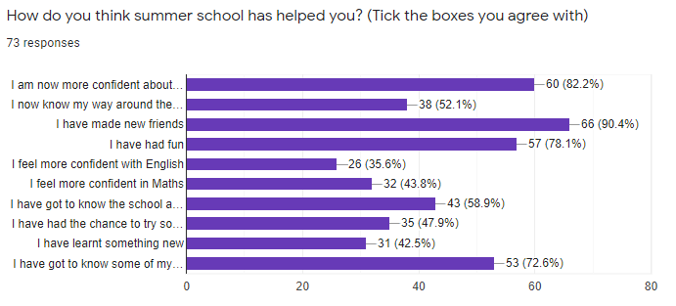

100% of parents (41 respondents) stated that their child had enjoyed attending summer school and that they were happy with the range of lessons and activities on offer.
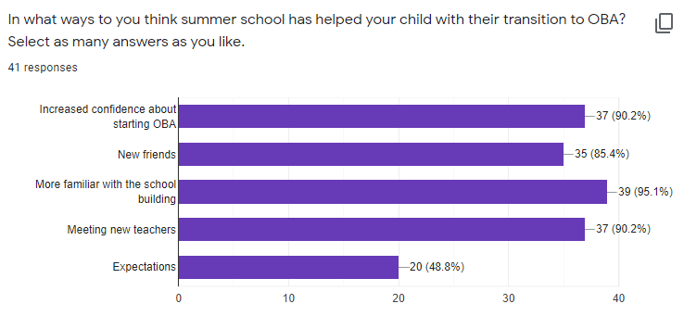

Additional comments from parents/carers:
Parent Comments:
- Cadu loved summer school and is excited to start at OBA. Thank you!
- I think this an amazing idea for new children especially as parents we worry about them not knowing people when they start. This has eased my own anxiety around her starting
- Excellent idea to help the children getting ready for September especially as they couldn't do the transition days this year
- It was amazing
- Think summer school is a really good transition for pupils letting them get their whereabouts of the school before they start in September, helps them meet other people so their first day will be some familiar faces for them. Gives teachers and pupils chance to meet each other.
- Oliver really enjoyed summer school. Thank you to all the Teachers and staff
- Really good to do this. It helped our daughter learn more about the school before she starts in September.
- My son was extremely nervous about Summer School but really enjoyed it. Thank You.
- Isaac is much more relaxed about starting in Sept since attending Summer school.
- I feel the summer school is excellent. I've had 2 children attend in the last few years and both have really enjoyed it. I hope it carries on until my next child passes through!

Future Considerations and ideas:
- Booklets will be given out at Induction evening next year if Covid-restrictions allow this event to go ahead face to face.
- Alternating Maths and English lessons throughout the morning worked well.
- Admin spreadsheet to include all of the following information on one document – name, form, group number, parent contact details including email address, photo consent, medical and SEND information, pupil premium eligibility, daily attendance.

